Signal Reconstruction (Reconstruction Filters)

A sampled signal can be reconstructed using one of many types of reconstruction filters. Consider the sequence of samples represented by a series of delta functions shown below.
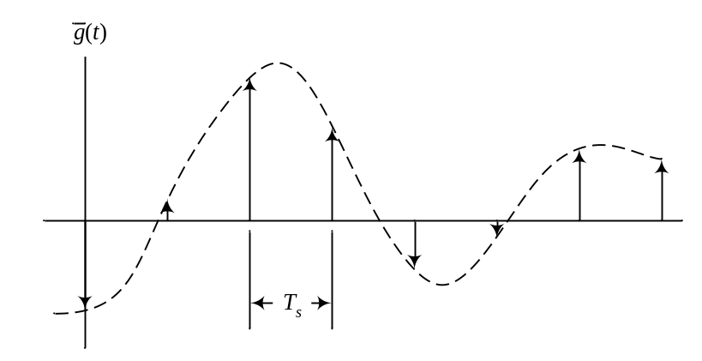
The signal g(t) can be reconstructed (recovered) from ‾g(t) using one of many reconstruction filters. For a reconstruction filter with impulse response h(t), the output signal of that filter y(t) is obtained by convolving the impulse response with the signal x(kT_{s}), or

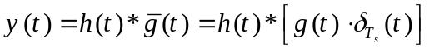.

Zero–Order Hold: Consider the filter h₀(t) with the impulse response shown below.
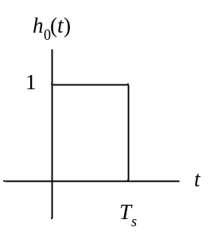
The reconstructed signal obtained by convolving h₀(t) with ‾g(t) can easily be shown to be as follows.
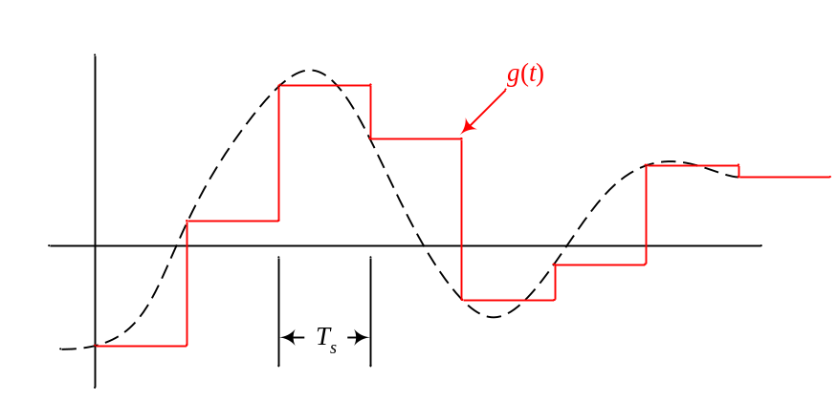

Since the result of convolution remains (is held) constant (as a line with zero–order) at the value of the previous sample until a new sample arrives, this gives the reason for calling this type of reconstruction filter a zero–order hold filter. The spectrum of this filter is like a sinc, which results in attenuating the side images of the sampled signal but not completely. This is the reason for not getting the original input signal to the sampling system exactly. Note that because of the shape of the impulse response of this filter, only one sample of the sampled signal contributes to the reconstructed signal at any instant of time.

First–Order Hold: Consider the filter h₁(t) with the impulse response shown below.
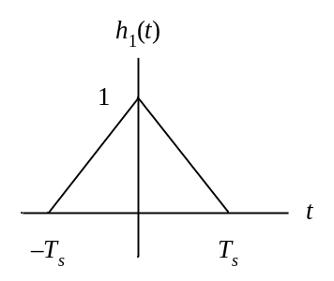
The reconstructed signal obtained by convolving h₁(t) with ‾g(t) can be shown to be as follows (by adding the different triangles shown using dashed lines).
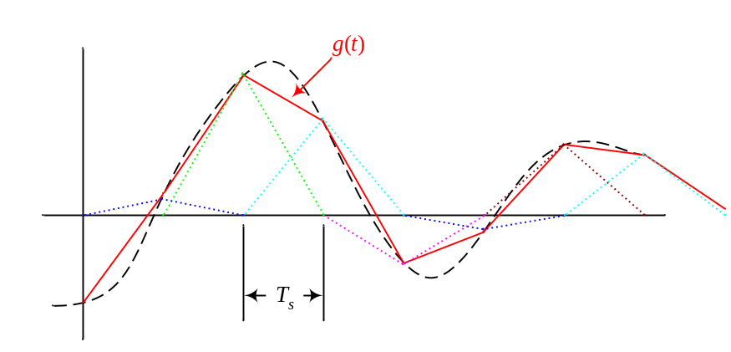

Since the result of convolution increases or decreases at a constant rate (the derivative is held constant) similar to a line with first–order degree) from a sample until the next sample arrives, this reconstruction filter is called a first–order hold filter. The spectrum of this filter is like a sinc², which results in attenuating the side images more than the attenuation provided by the zero–order hold reconstruction filter but again not completely. This is the reason for not getting the original input signal but a better reconstructed signal than obtained by the zero–order hold filter. Note that due to the shape of the impulse response of this reconstruction filter, two successive samples contribute to the output reconstructed signal at any instant of time.

Sinc Filter (Infinite–Order Hold): Consider the filter h∞(t) with the impulse response shown below.
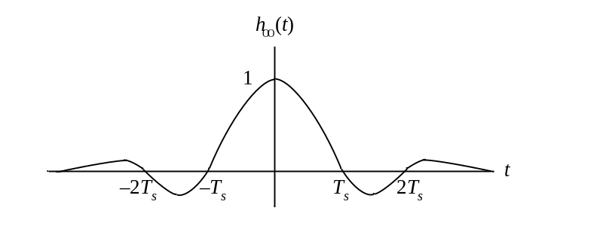
The reconstructed signal obtained by convolving h∞(t) with ‾g(t) can be shown to be as follows (by adding the different sinc functions shown using dashed lines).
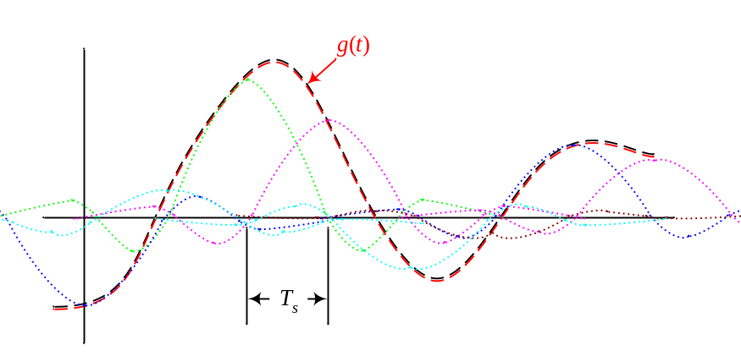

This filter acts like an extension to the zero–order hold, first–order hold, second–order hold, … reconstruction filters. In fact, the zero–order hold uses one sample at a time to reconstruct the original signal, the first–order hold uses two samples, the second–order hold uses three, … , and this filter uses an infinite number of samples justifying the "∞-order" used in naming this filter. The spectrum of this filter is a rect, which results in attenuating all the adjacent images completely. This is the only filter that reconstructs the original signal that is input to the sampling system exactly.

